Land Use and Walkability
Student’s Name
Institutional Affiliation

Land Use and Walkability
My neighborhood is Glassell Park in Los Angeles that has almost 23,467 residents and covers 2.75-square-mile of land. The community has many social amenities, including schools, restaurants, shops, post offices, parks, swimming pools, churches, etc. The area is used mostly for single-family residential, open spaces, and commercial purposes. However, the most prevalent use of land is for commercial purposes. The most notable landmarks are Steele Spring Stage Right, Glassell Park Recreation Center Complex, Glassell Park Child Care, Eagle Rock Blvd Avenue, Division Street, and Glassell Park Elementary School. The zoning code for the municipality is 11.5.7.
Zoning Map
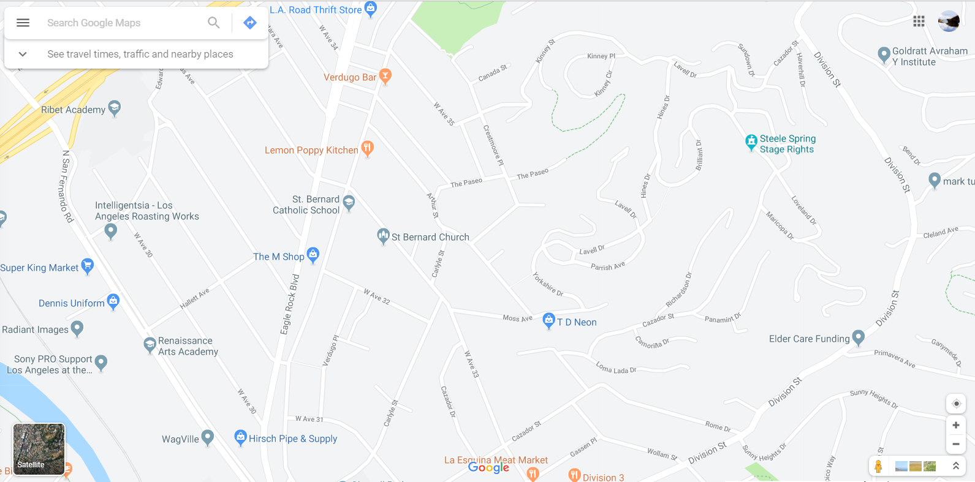
The distance from my house to St. Bernard Church is 0.4 mile, Elder Care Funding (0.7 miles), La Esquina Meat Market (0.1 miles), Papa Jones Pizza (1.7 miles), and Glassell Park Eagle Rock Blvd (0.7 miles), Super A Foods (0.3 miles), Recreation Center Complex (1 mile). The walking time to Supper A Foods is 6 minutes, La Esquina Meat Market (1 minute), Elder Care Funding (14 minutes), St. Bernard Church (7 minutes), Papa Jones Pizza (25 minutes), Recreation Center Complex (15 minutes), and Eagle Rock Blvd (14 minutes).
The land use in Glassel Park neighbor enables easy movement from one amenity to another. Commercial buildings and units are not far away from the single-family residences in the area. Also, their land use enables access to open places such as markets and parks. The essential amenities are not far away from residential units; as a result, persons can walk to these areas. Besides, these amenities are accessible through numerous roads. Buildings and building entrances allow pedestrians to use the roads without conflicting with automobile users. Commercial units are adjacent to sidewalks to create a vibrant business environment that can be accessed by any person walking in the streets (Cypress Park and Glasell, 2009). Community services are accessible along existing commercial corridors; therefore, residents of the neighborhood can do their shopping and visit a health care facility a few miles away. Notably, it has an appreciable pedestrian scale since human bodies do not exceed the bulk of the buildings.
Zoning influenced the distance between my house and amenities since the Los Angeles municipality requires residential and commercial units to comply with a minimum required area. Also, the land has permitted uses for residential planned development integrated with a booming business environment. As a result, the distances between residential and amenities are significantly reduced.
The neighborhood is characterized by mixed land use since it has blended residential, cultural, commercial, institutional, and entertainment units into one space. In this regard, there are pizza joints, churches, museums, schools, and residential units in one space. Separation of land is evident in the area since the Glassell Swimming Pool, and the Glassell Park Recreation Center Complex is situated nearby to each other for entertainment purposes. Mixed land use is beneficial as compared to the separation of since it encourages a variety of architectural designs that improve the aesthetic appearance of the neighborhood. Unlike the separation of land, it encourages infrastructural development in compact pieces of land. Most importantly, it has reduced pollution in the area since people use vehicle less often to access amenities. The only change I would make to my neighborhood is to increase the number of food joints to enhance walkability. Also, I suggest that the location of the Rite Age (drug store) be located more to the Eagle Rock Blvd Avenue to ease its accessibility. I will also increase the minimum required parking spaces for commercial areas to one and allocate more to residential areas to promote walking among the population.

Reference
Cypress Park & Glassel Park. (2009). Community design overlay: Design guidelines and
Development standards, 1-45.

